MERN WS

Packages to install in vs terminal

(open mern folder)

Cd client

npm install @mui/material @emotion/react @emotion/styled

npm i @mui/icons-material

npm i jwt-decode

npm i @react-oauth/google

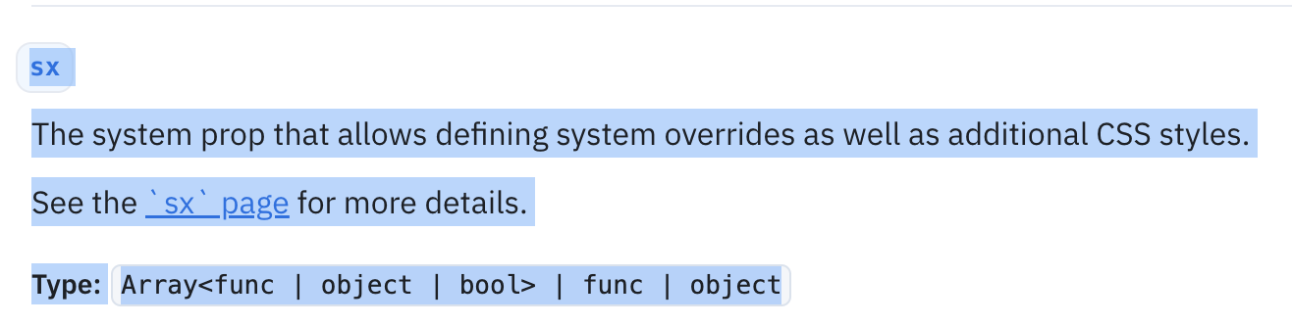

<https://www.npmjs.com/package/@react-oauth/google>

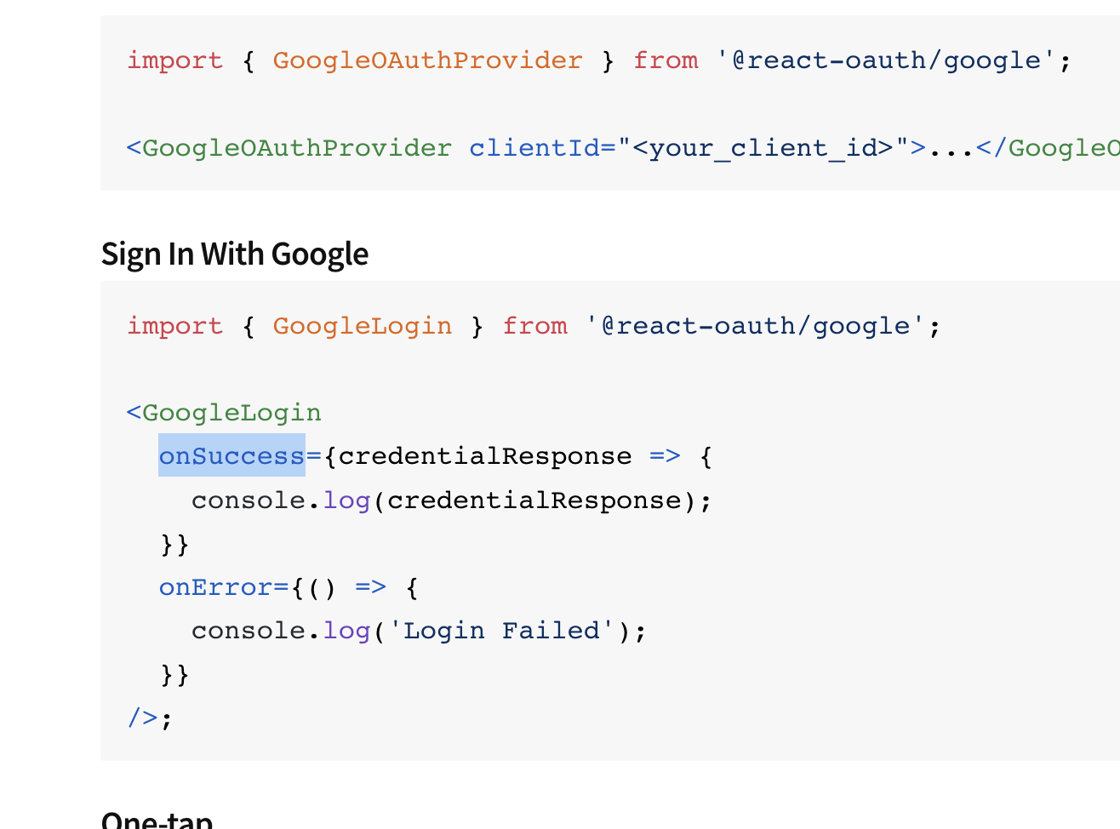

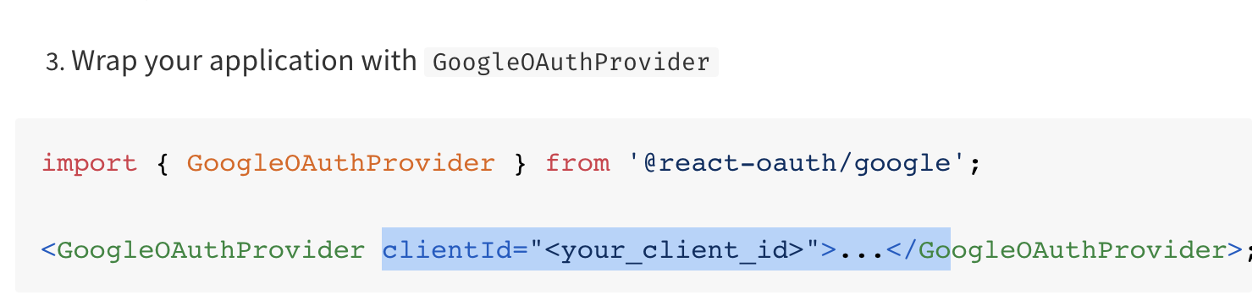

Console.cloud.google.com

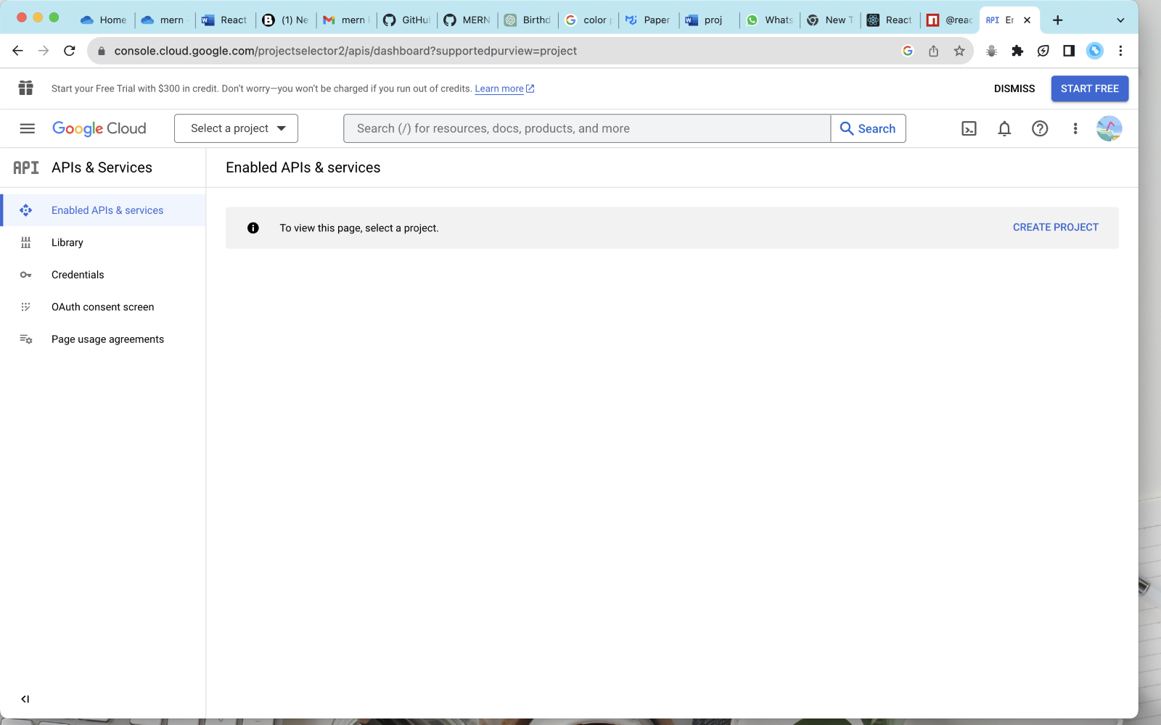

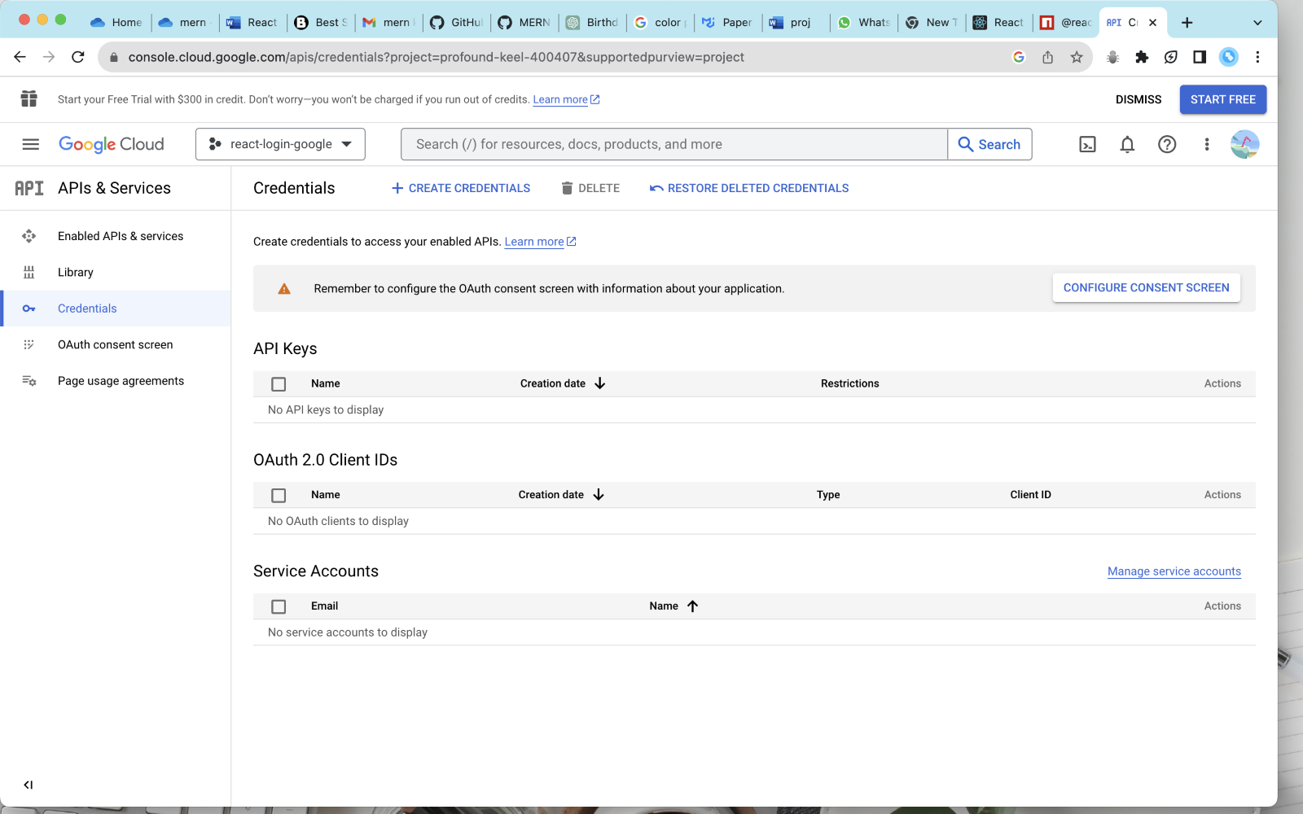

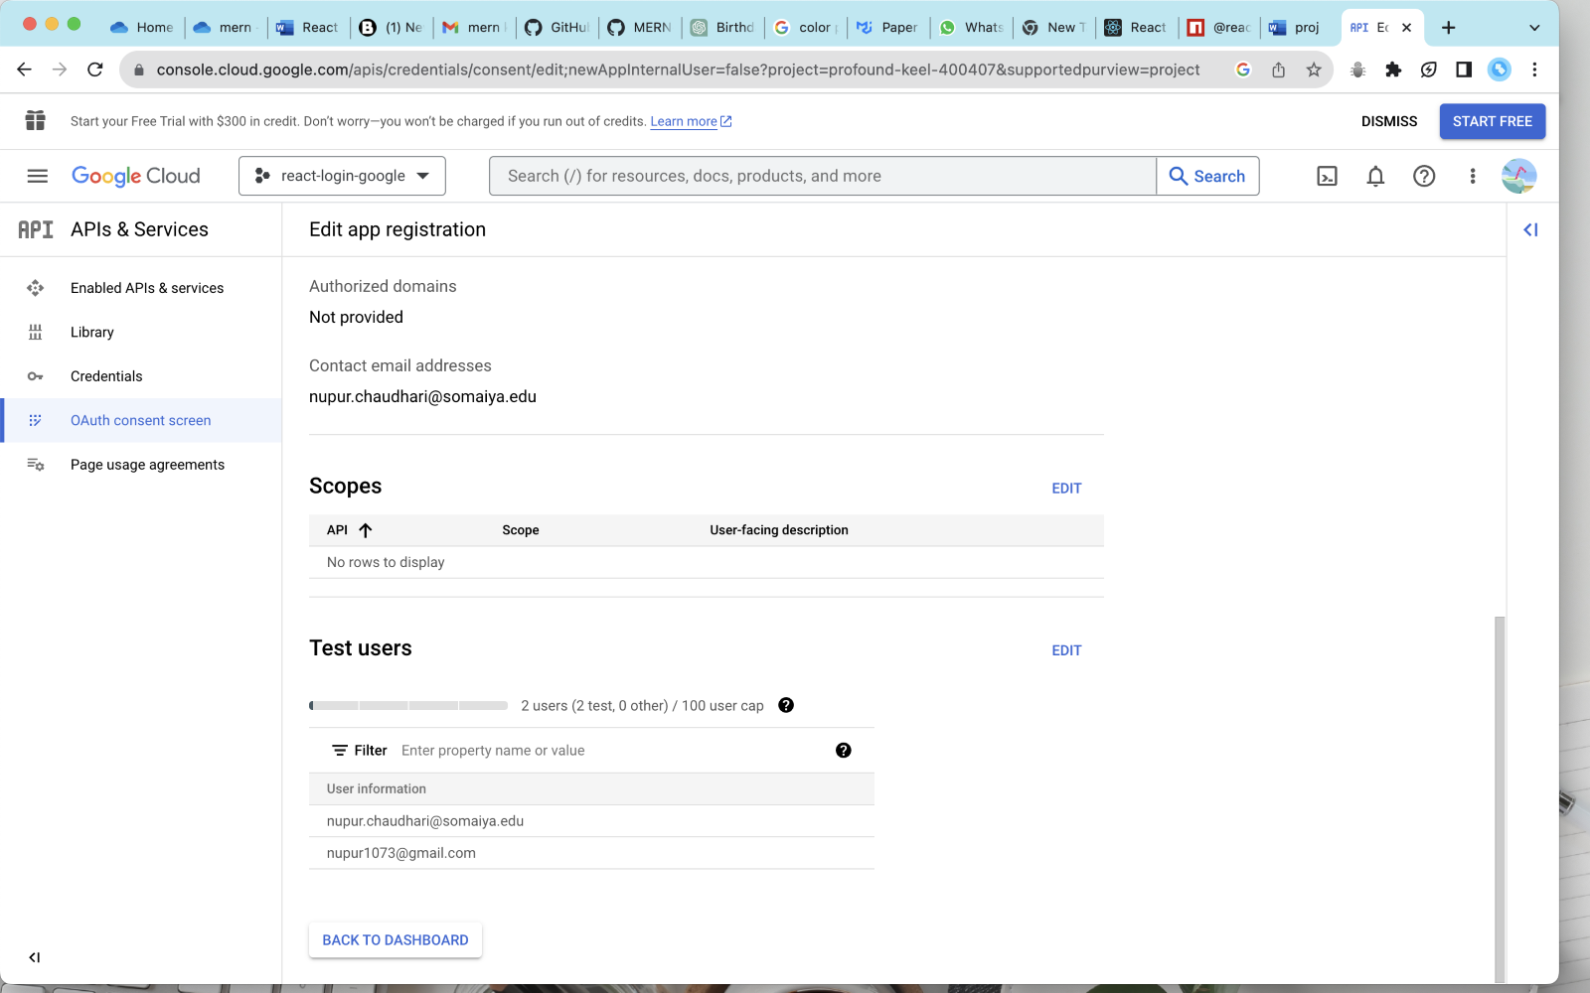

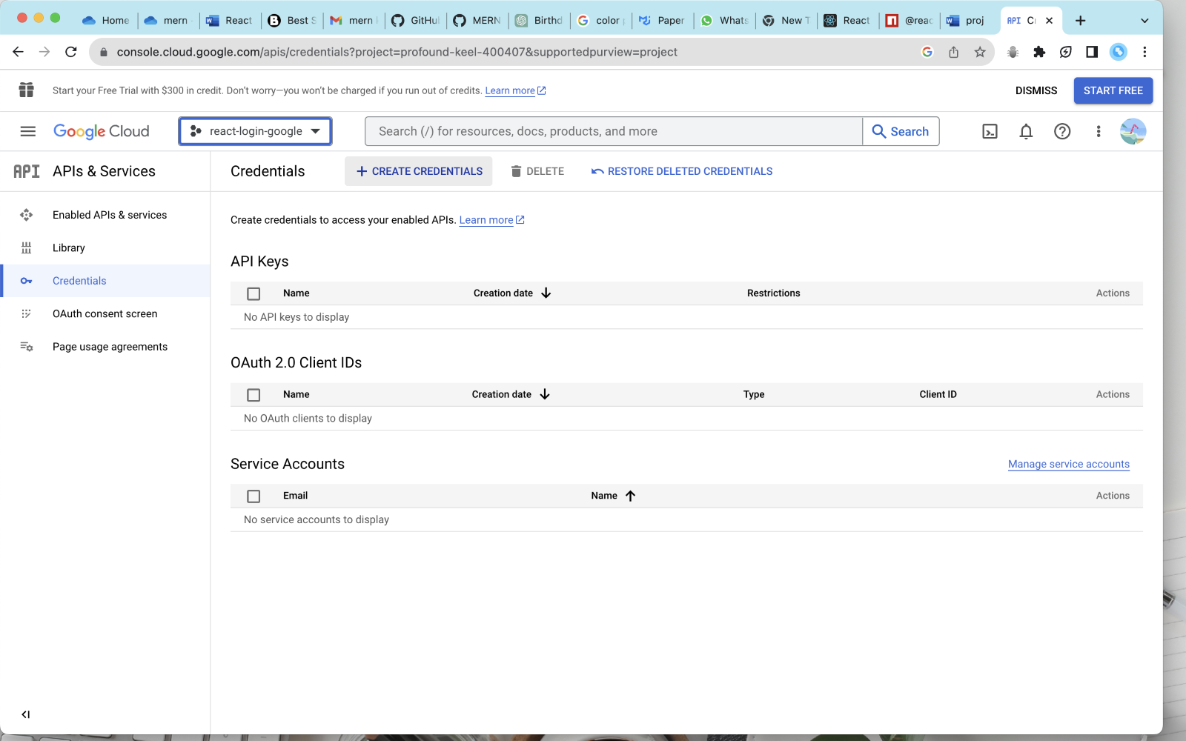

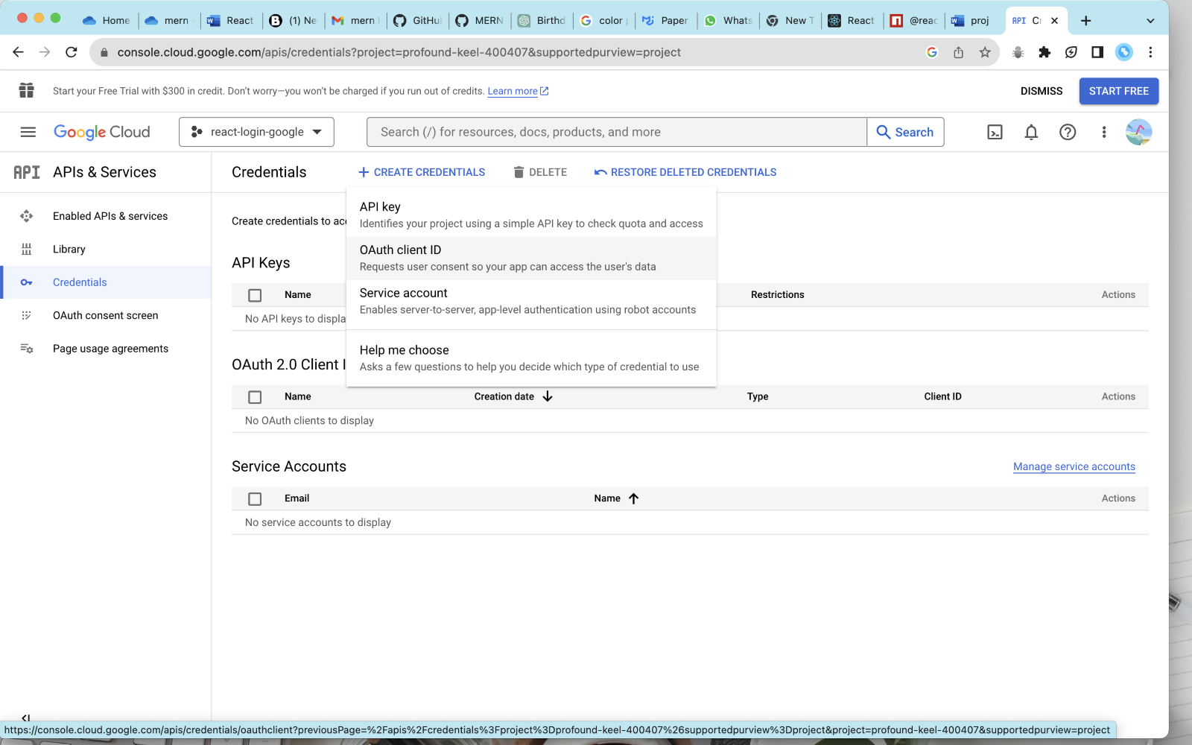

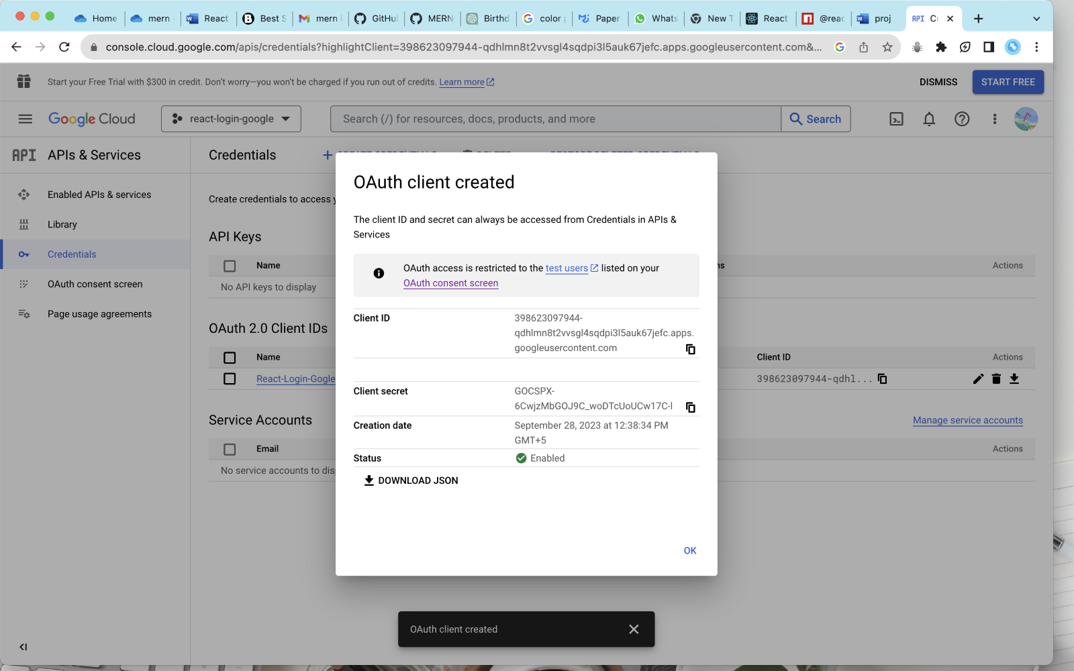

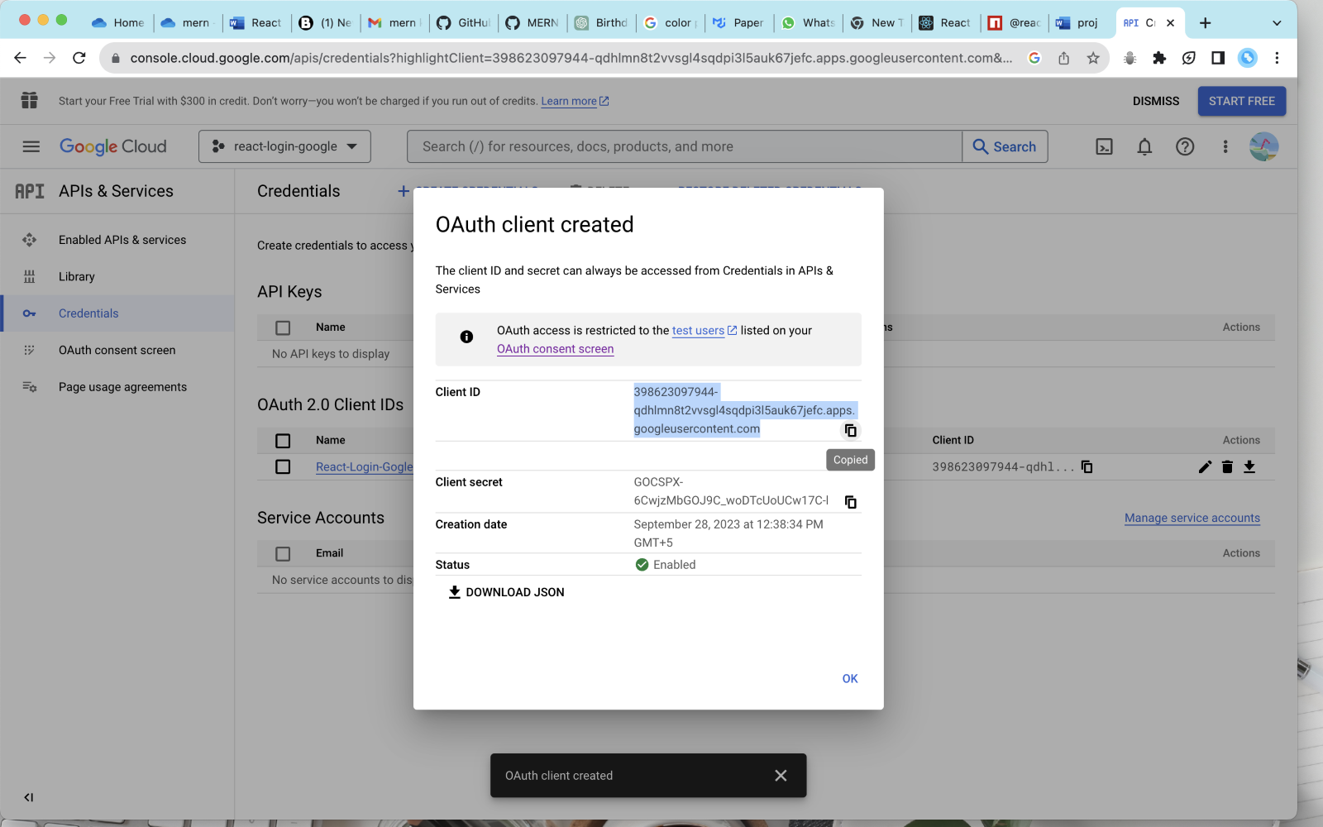

OAuth??

React devloper tools download?

Api working google?

Double curly braces why?

= () => {}. Iska meaninig ?

State in react ?

Hook ?

State variable ?

Wrapping components?

*Component k andr pass karne k 2 ways : either prop or childeren*

*Eg children : messenger is a children*

*<AccountProvider>*

*<Messenger />*

*</AccountProvider>*

*Eg prop:*

*<GoogleOAuthProvider clientId={clientId}>*

*</GoogleOAuthProvider>*

After signin .. credentials will be encrpted form ..

to decrypt it .. install npn I jwt-decode .. it’s a apackage

O/p after login:

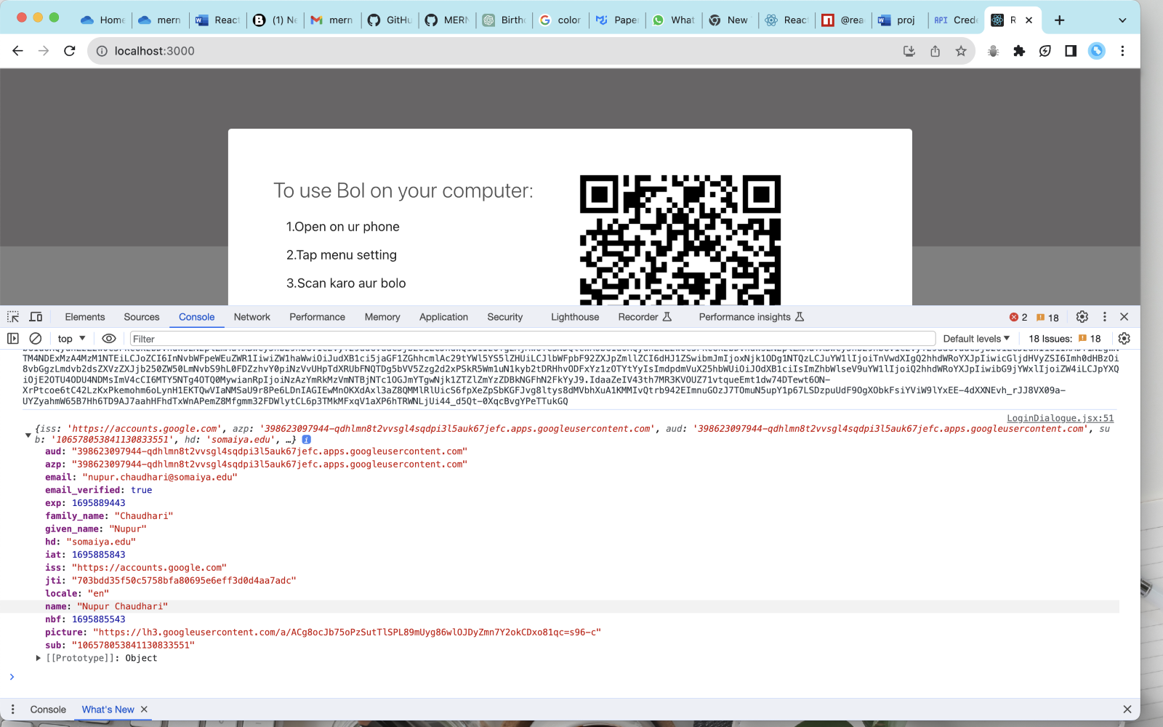

(pehle bass credentials and clientid aa raha tha .. credentials m encoded encrypted info of the loged in user tha

After using jwt-decoder package .. humne decrypt kar liya credentials ko .. and then aisa in detail info of login in user mmil raha h )

Picture : google profile pic

Sub : unique key

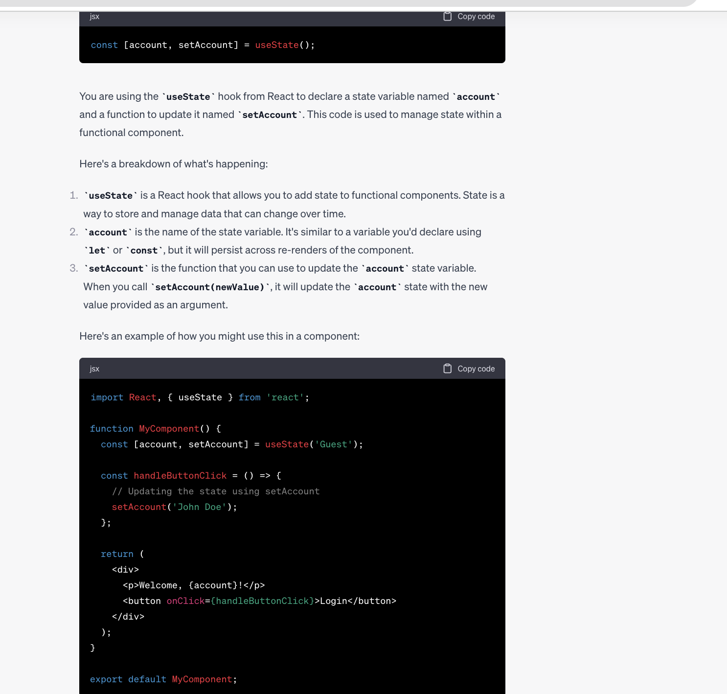

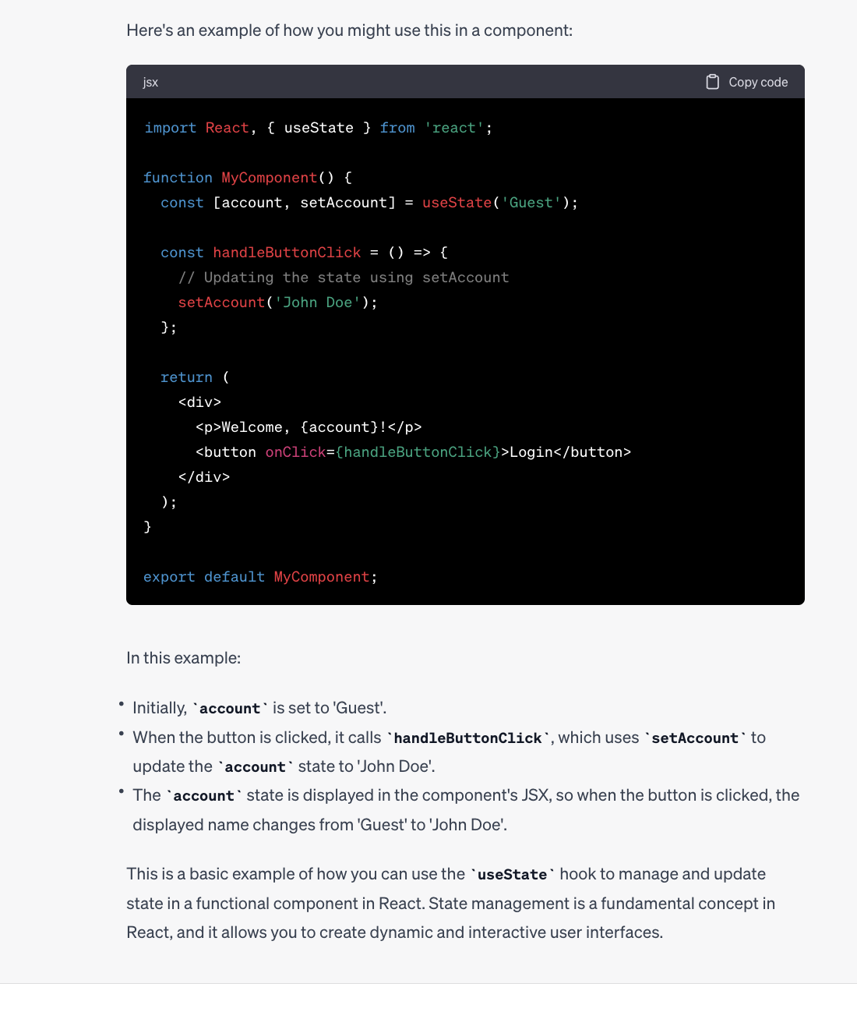

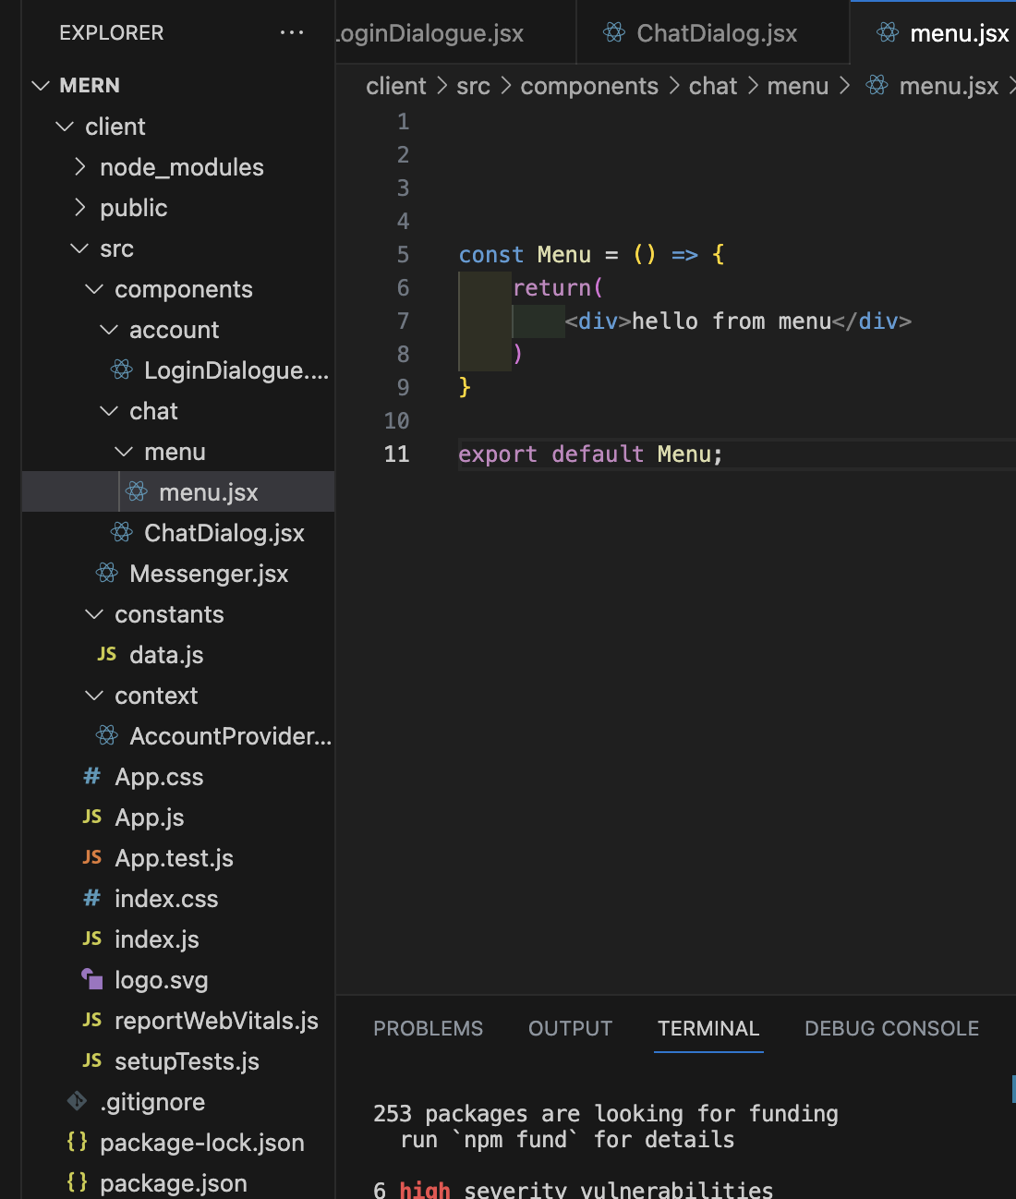

Colour pallete

https://colorhunt.co/palette/f8f0e5eadbc8dac0a30f2c59

_______________________________________________________________

SOURCES  
  
common drive jispe apn kaam upload karenge

https://drive.google.com/drive/folders/1fk0IqyecybowURYikU_UtIkhUw73h3cD?usp=sharing

colours used .. retro ..

https://colorhunt.co/palette/f8f0e5eadbc8dac0a30f2c59

mui official site..(bootstrap basicallly)

https://mui.com/material-ui/react-drawer/#keep-mounted

api google

<https://console.cloud.google.com/apis/credentials?highlightClient=398623097944-qdhlmn8t2vvsgl4sqdpi3l5auk67jefc.apps.googleusercontent.com&project=profound-keel-400407&supportedpurview=project&pli=1>

og git code ytber ka

https://github.com/kunaltyagi9/MERN-Stack-Projects/tree/master/Whatsapp-Clone

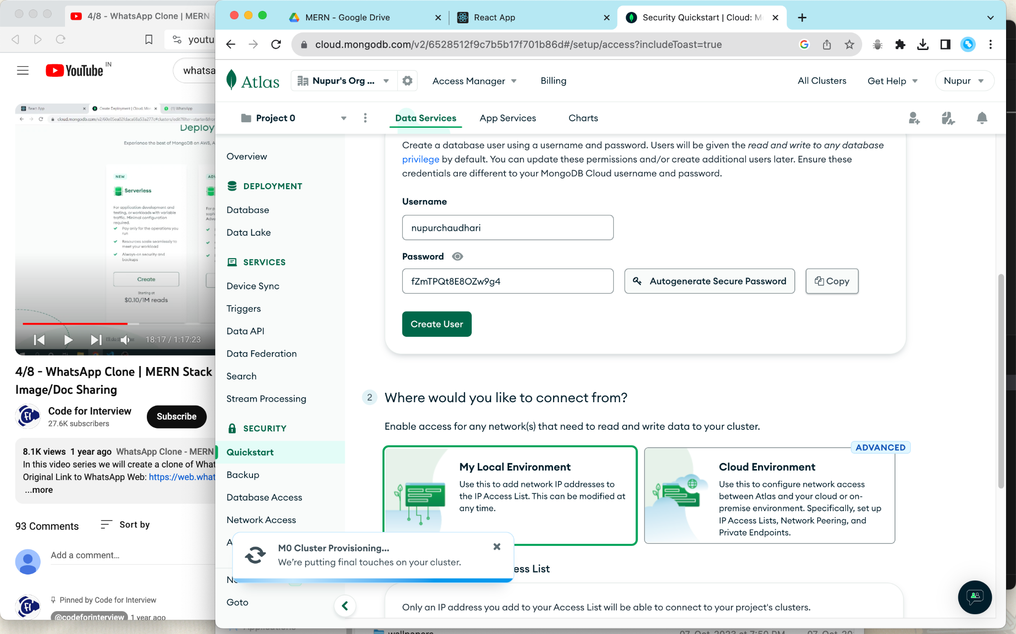

Attach file

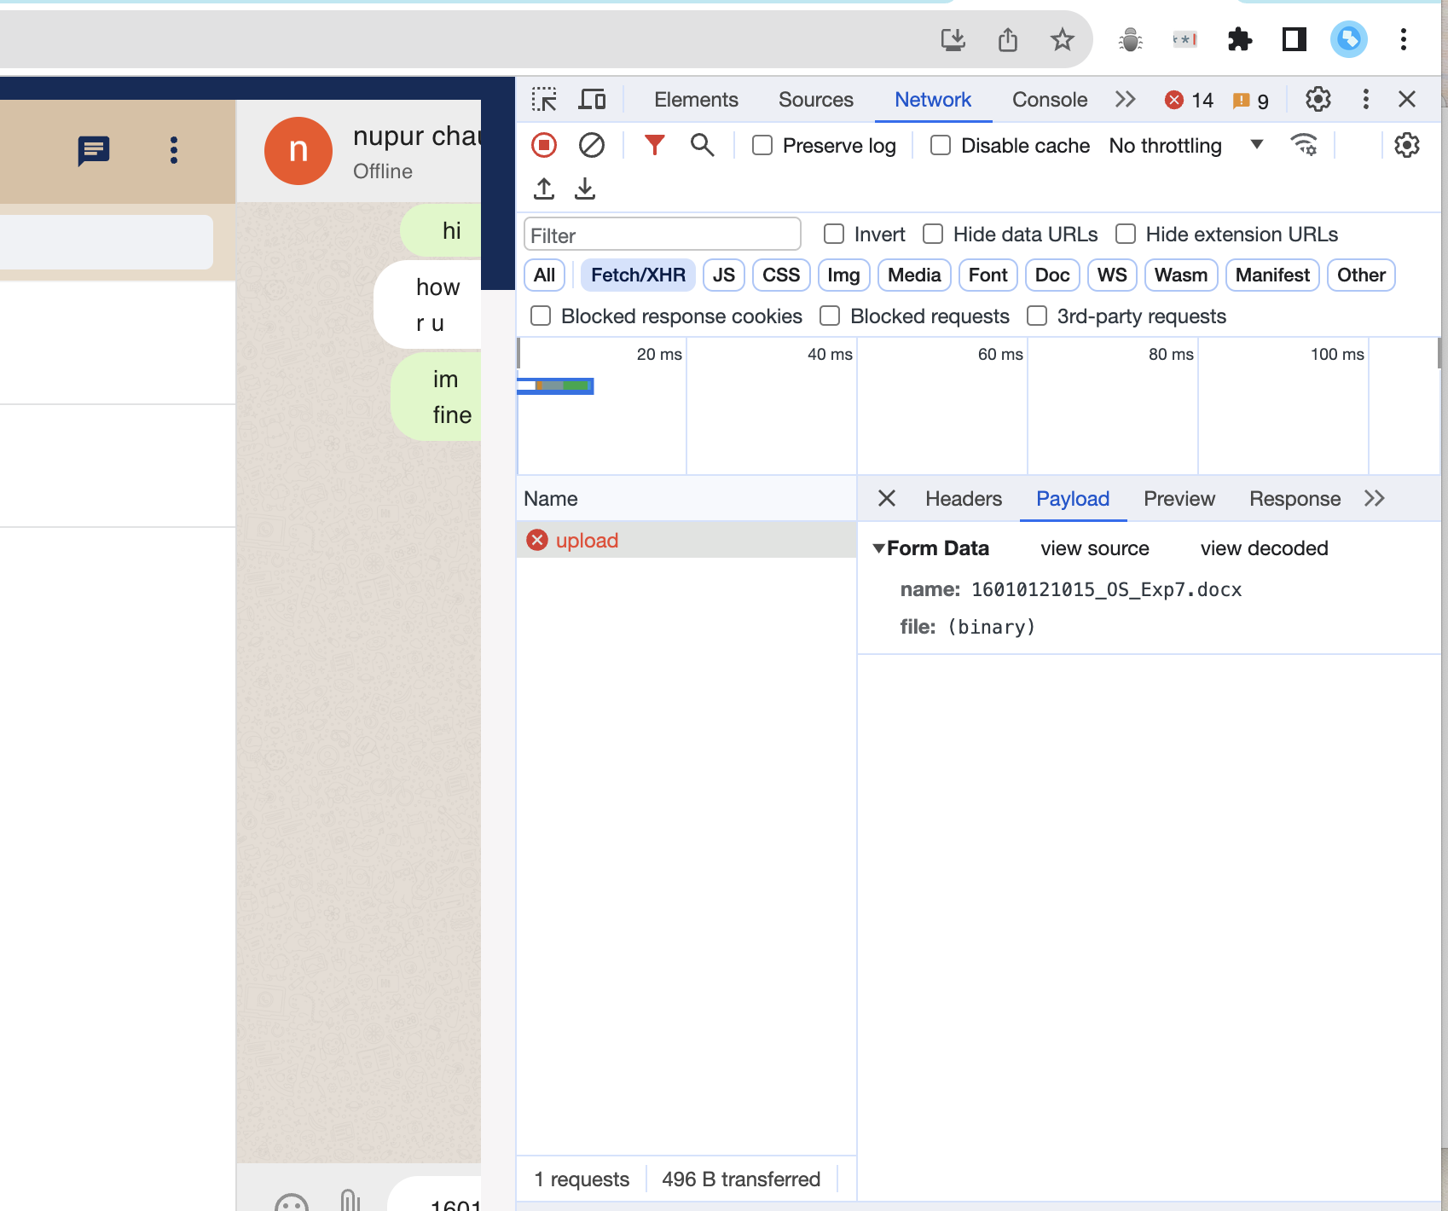

File goes in binary format

Server m install forattach file storage in db

npm i multer

npm i multer-gridfs-storage

upload.js

<https://www.npmjs.com/package/multer-gridfs-storage>

27:38 / 1:05:37

If port is non vacant

lsof -i :8000

kill -9 PID

